NEW EMPLOYEE TRAINING REQUIREMENTS

HR REQUIREMENTS:

- Moody Drug-Free School Act & Training

- Employee Information Guide (EIG)

- ANCRA Sign off

Call Human Resources at x4237 for further inquiry regarding the above trainings.

INSTITUTE REQUIREMENTS:

- Doctrinal Statement
  - Main Contact: Mary Oliva of the President’s office
    - Email: mary.oliva@moody.edu
    - Phone: 312 329 4112

- Workplace Safety Training
  - Main Contact: Stacey Craelius of Public Safety
    - E-mail: stacey.craelius@moody.edu
    - Phone: 312 329 4405

- Moody Title IX Policy Training
  - Main Contact: Trinity Cortez, Title IX Coordinator
    - E-mail: trinity.cortez@moody.edu
    - Phone: 312 329 4022

- Cyber Security Awareness Training
  - Main Contact: Joe Straw of ITS
    - Email: joe.straw@moody.edu
    - Phone: 312 329 4395

- Intercultural Development Inventory (IDI)
  - Main Contact: Lud Anderson of Human Resources
    - Email: ludwig.anderson@moody.edu
    - Phone: 312 329 4482

HOW TO ACCESS REQUIRED TRAINING MATERIALS:
Recommended Web Browser: Internet Explorer

- Log in to myMoody by navigating to my.moody.edu
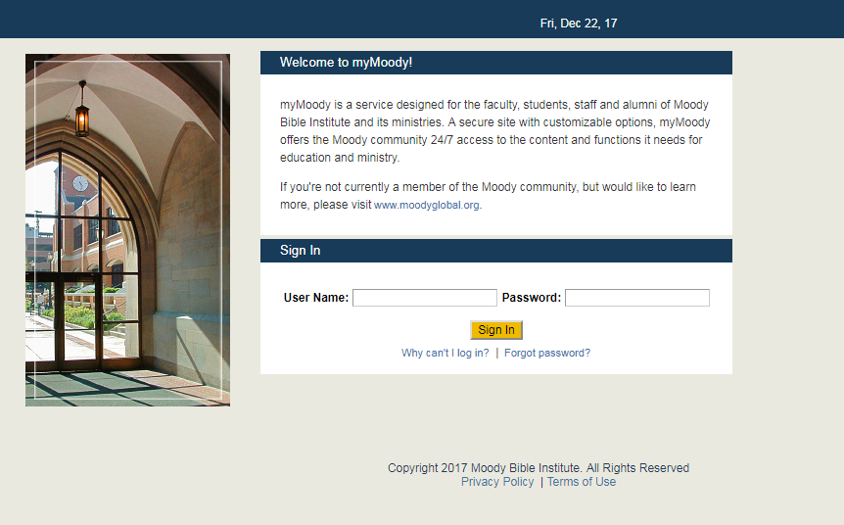

- Navigate to the Staff tab and then go to ‘Directory by Department’
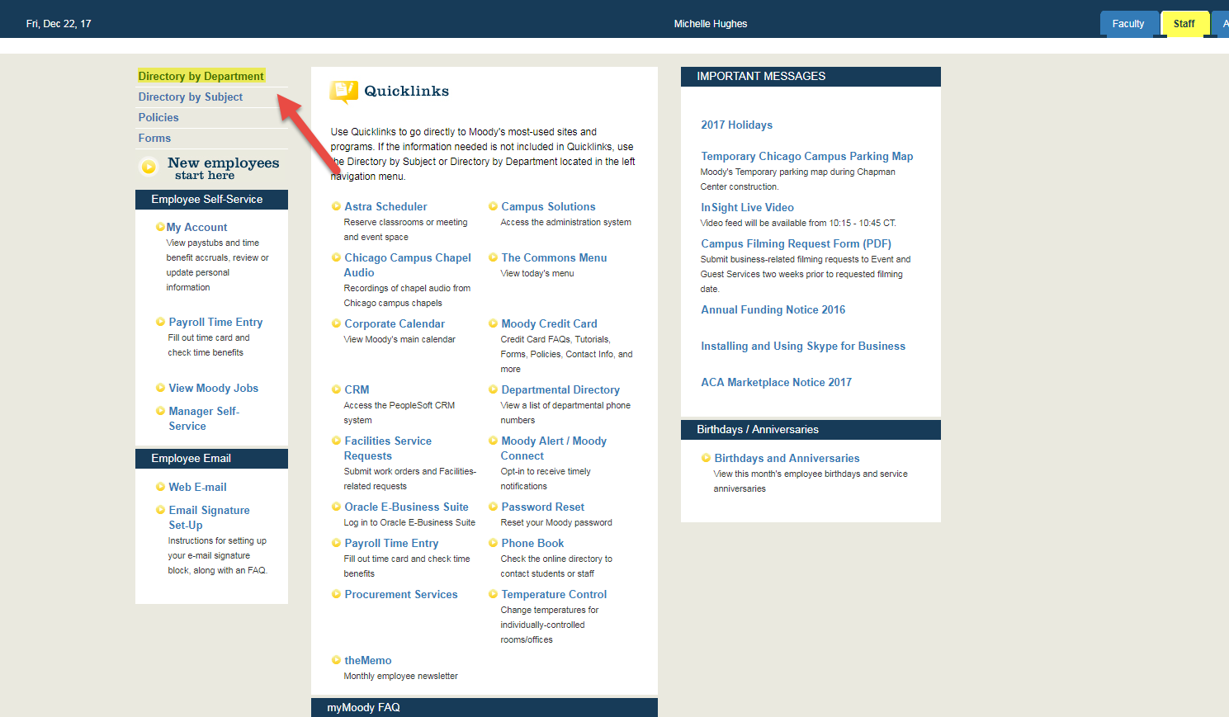

- Under Human Resources, select ‘Employee Learning/Development’. (Note that the EIG and ANCRA sign-offs can be found on this page without navigating to the Employee Learning/Dev page.)
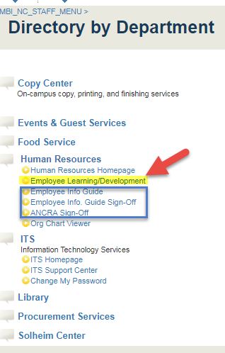

- Once on the Employee Learning/Development site, select New Employee Resources. Here you will find a list of sign-offs that are required for HR and other departments.

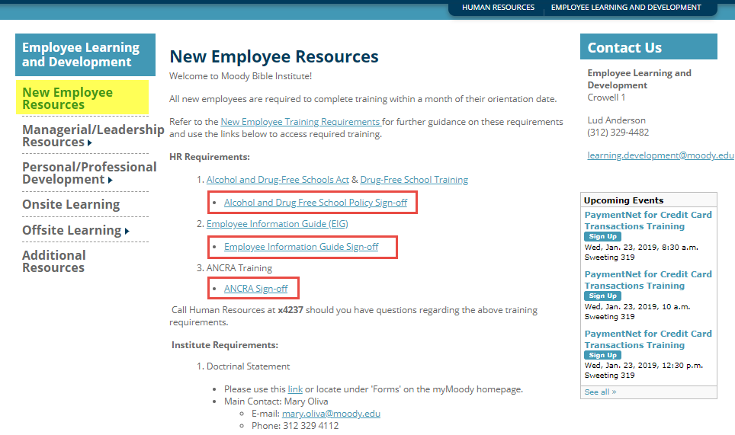

(More Institute requirements on next page)

For Workplace Safety Training:
Safety Training Website - https://www.osmanager4.com/logindynamic.aspx

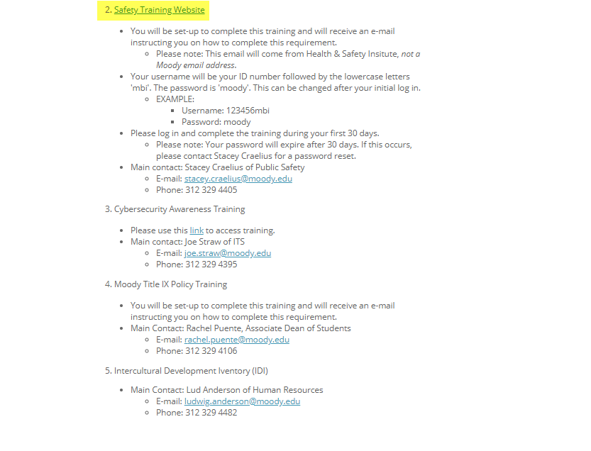
- You will be set up to complete this training and will receive an e-mail instructing you on how to complete this requirement.
  - Please Note: This email will come from Health & Safety Institute, not a Moody email address.
- Your username will be your ID number followed by the lowercase letters ‘mbi.’ The password is ‘moody.’ This can be changed after your initial log-in.
  - EXAMPLE
    - Username: 123456mbi
    - Password: moody
- Please log in and complete the training during your first 30 days.
  - Please Note: Your password will expire after 30 days. If this occurs, please email Stacey Craelius for a password reset.

