For Family Status Changes, please follow the screenshot below:

Login to [UKG Pro](https://myapplications.microsoft.com/) 🡪Myself🡪Manage my Benefit🡪Update My Benefits🡪Select Life Event🡪Review

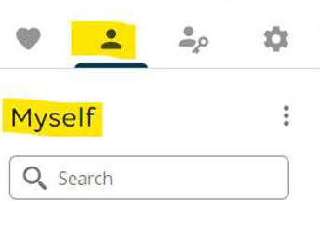

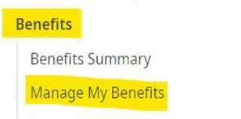

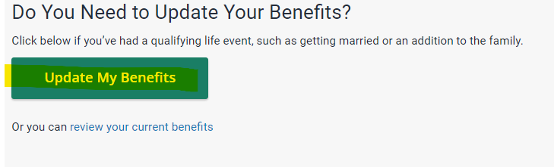

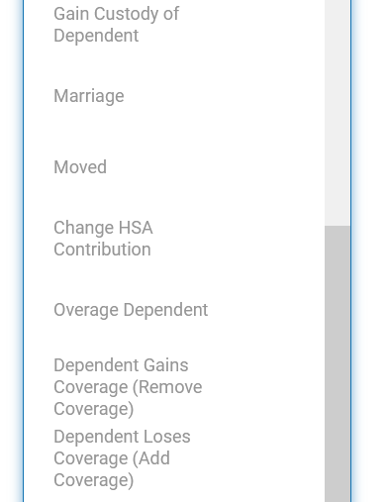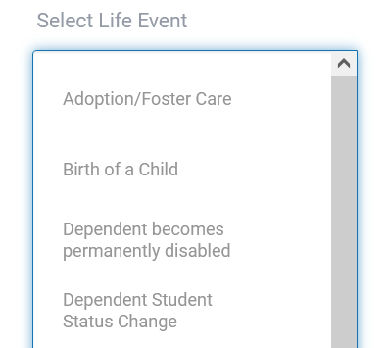

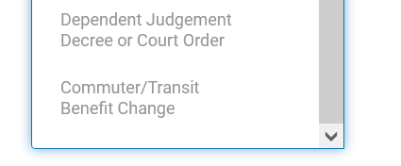**.**

**Please submit required documents through UKG.**